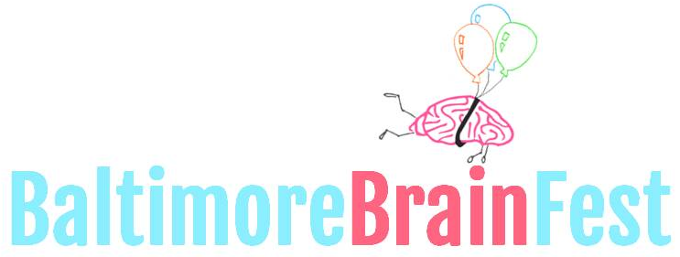

LIBERTY RECREATION CENTER
3901 MAINE AVE, BALTIMORE 21207
10AM-4PM SATURDAY 10.14.2017
WWW.BRAINFEST.ORG
BALTIMOREBRAINFEST@GMAIL.COM

DEMONSTRATOR INTEREST FORM

Thank you for partnering with the second annual Baltimore Brain Fest! Project Bridge is excited to be working with you to bridge science and the community through a fun and exciting event. We believe that dynamic and engaging demonstrations using brain sciences is an effective and fun way to introduce and expand the public’s perception of science research. We look forward to the exciting responses from your demonstrations! Below are details that we hope will answer any questions you may have, as well as requests for information we will need from you as a Demonstration Exhibitor.

Our Goal: To connect science to the community, we aim to create excitement about science, encourage science as a career path, and create new advocates for science.
The Audience: The event is open to the public. Although we expect many K-12 students along with their families, collegiate and post-collegiate students, and other adult professionals are expected. There is no requirement for your demonstration to target all audience members.
Expectations: Booths must be set up by 10AM, and must be staffed at all times, from 10AM-4PM. No open flames, explosions, knives, piercing projectiles will be allowed. Any and all biohazardous materials must be handled by a trained expert. Safety for all participants is our number one concern!
Deadline: Please email this document to baltimorebrainfest@gmail.com by September 1st.

Each booth includes:
One 10ft table with 2-4 chairs | Electric cord | Up to 4 t-shirts for volunteers
Table cloth | Wireless internet | Snacks, water, and lunch*

*let us know if a member of your team has dietary restrictions

Please provide the following information:
Coordinator Name: Click here to enter text. Email: Click here to enter text. Phone: Click here to enter text. Organization Name: Click here to enter text. Organization Website: Click here to enter text.

Goal of Demonstration: Click here to enter text.

Describe the demonstration and its relationship to brain science. Include all materials, if any, you plan to give away [demonstrations with no clear connection to brain science are accepted if it fulfills the goal to connect science and community]: Click here to enter text.

What is your intended audience [select all that apply]:
k-6 7-12 college adult other

Interested in presenting on the main stage for 15 minutes? Choose an item.

Volunteer Information (include ALL expected volunteers):
- Name: Click here to enter text. Email: Click here to enter text. T-shirt size: Choose an item.
- Name: Click here to enter text. Email: Click here to enter text. T-shirt size: Choose an item.
- Name: Click here to enter text. Email: Click here to enter text. T-shirt size: Choose an item.
- Name: Click here to enter text. Email: Click here to enter text. T-shirt size: Choose an item.

Select set-up time [select all that apply]
Friday, 10.13.2017 at 5PM-7PM: Can drop off materials, but cannot set up table until Saturday
Saturday, 10.14.2017 at 8AM-10AM: Set up table

Your name and website will also be included in promotional materials not limited to website, flyers, and banners. For further questions, please email us at baltimorebrainfest@gmail.com

