LIBERTY RECREATION CENTER
3901 MAINE AVE, BALTIMORE 21207
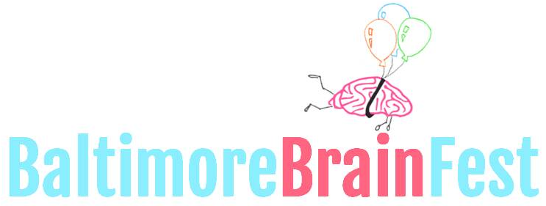
10AM-4PM SATURDAY 10.14.2017
WWW.BRAINFEST.ORG
BALTIMOREBRAINFEST@GMAIL.COM

COMMUNITY RESOURCE INTEREST FORM

Thank you for partnering with the second annual Baltimore Brain Fest! Project Bridge is excited to be working with you to bridge science and the community through a fun and exciting event. We believe that equipping Baltimore citizens with effective health and wellness resources is essential to empower the community to thrive. Along with dynamic and engaging demonstrations using brain sciences, your involvement will expand the public’s perception of science research. Below are details that we hope will answer any questions you may have, as well as requests for information we will need from you as a Resource Exhibitor.

Our Goal: To connect science to the community, we aim to create excitement about science, encourage science as a career path, and create new advocates for science.
The Audience: The event is open to the public. Although we expect many K-12 students along with their families, collegiate and post-collegiate students, and other adult professionals are expected. There is no requirement for your demonstration to target all audience members.
Expectations: Booths must be set up by 10AM, and must be staffed at all times*, from 10AM-4PM. No open flames, explosions, knives, piercing projectiles will be allowed. Any and all biohazardous materials must be handled by a trained expert. Safety for all participants is our number one concern! One representative must attend a mandatory orientation in August for all community partners, date TBA.
Deadline: Please email this document to baltimorebrainfest@gmail.com by September 1st
*If you are unable to make it on the day of the event, but would still like to provide your resources to participants, you may arrange to meet a Brain Fest team member the week prior to the event and provide your items. We will provide them to participants at a general information/sponsors table staffed by the Brain Fest team.

Each booth includes:
One 10ft table with four chairs | Electric cord | Up to 4 t-shirts for volunteers
Table cloth | Wireless internet | Snacks, water, and lunch

Please provide the following information:
Coordinator Name: Click here to enter text. Email: Click here to enter text. Phone: Click here to enter text. Organization Name: Click here to enter text. Organization Website: Click here to enter text.

Describe the resources you will provide to festival goers. Include intangible and physical products. Include all materials, if any, you plan to give away Click here to enter text.

What is your intended audience [select all that apply]:
k-6 7-12 college adult other

Interested in presenting on the main stage for 15 minutes? Choose an item.

Volunteer Information (include ALL expected volunteers):
- Name: Click here to enter text. Email: Click here to enter text. T-shirt size: Choose an item.
- Name: Click here to enter text. Email: Click here to enter text. T-shirt size: Choose an item.
- Name: Click here to enter text. Email: Click here to enter text. T-shirt size: Choose an item.
- Name: Click here to enter text. Email: Click here to enter text. T-shirt size: Choose an item.

Select set-up time [select all that apply]
Friday, 10.13.2017 at 5PM-7PM
Saturday, 10.14.2017 at 8AM-10AM

Your name and website will also be included in promotional materials not limited to website, flyers, and banners. For further questions, please email us at baltimorebrainfest@gmail.com

