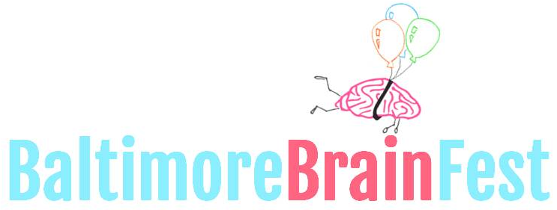

LIBERTY RECREATION CENTER
3901 MAINE AVE, BALTIMORE 21207
10AM-4PM SATURDAY 10.14.2017
WWW.BRAINFEST.ORG
BALTIMOREBRAINFEST@GMAIL.COM

SPEAKER INTEREST FORM

Thank you for partnering with the second annual Baltimore Brain Fest! Project Bridge is excited to be working with you to bridge science and the community through a fun and exciting event. We believe that dynamic and engaging talks is an effective and fun way to introduce and expand the public’s perception of science research. We look forward to the exciting responses from your talk! Below are details that we hope will answer any questions you may have, as well as requests for information we will need from you as a Speaker.

Our Goal: To connect science to the community, we aim to create excitement about science, encourage science as a career path, and create new advocates for science.
The Audience: The event is open to the public. Although we expect many K-12 students along with their families, collegiate and post-collegiate students, and other adult professionals are expected. There is no requirement for your demonstration to target all audience members. Audience questions can range from broad societal implications to technical scientific details.
Expectations: After a quick introduction by our facilitator, you will have 10-15 minutes to present on your topic. There will an easel and markers. No other types of visuals are encouraged, as it detracts from a clear and concise presentation. The presentation will be followed by a 20 minute Q and A from the audience. Our facilitator will assist in fielding questions. Please arrive 30 minutes BEFORE your scheduled time.

Deadline: Please email this document to baltimorebrainfest@gmail.com by September 1st.

Please provide the following information:
Speaker Name: Click here to enter text. Email: Click here to enter text. Phone: Click here to enter text. Organization Name: Click here to enter text. Website: Click here to enter text.
Proposed Title: Click here to enter text.

Provide 3-5 sentences of your talk summary: Click here to enter text.

Describe the resources you will provide to festival goers. Include intangible and physical products. Include all materials, if any, you plan to give away Click here to enter text.

What is your intended audience [select all that apply]:
k-6 7-12 college adult other

Your name will also be included in promotional materials not limited to website, flyers, and banners. For further questions, please email us at baltimorebrainfest@gmail.com

